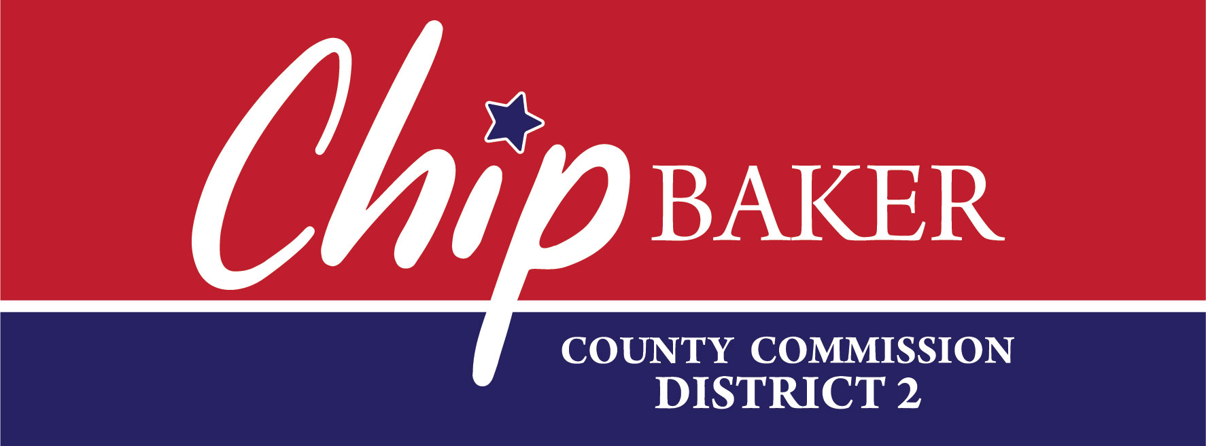
 | FOR IMMEDIATE RELEASE  August 25, 2025
  Contact | Dalton Temple
  Telephone | 678-232-6254
  Email | dalton@hillcitystrategies.com
  Website | www.chipbakercommission.com

Chip Baker Announces Re-Election Bid for Hamilton County Commission
Signal Mountain, TN – Chip Baker, current Hamilton County Commissioner representing District 2, announced today, his intention to seek a third term. Baker states that his focus remains steadfast: safeguarding property rights, ensuring controlled, responsible growth, accelerating and prioritizing infrastructure needs, and keeping our neighborhoods and families safe.
“Serving Hamilton County is a true honor,” said Baker. “I’ve worked diligently in serving my constituents with conservative principles. I look forward to continuing to do so over the next four years, and I will remain readily accessible to the needs of the taxpayers of Hamilton County.”
Commissioner Baker has a long history of public service since he and his wife moved to Chattanooga for his job as the Administrator of Children’s Hospital at Erlanger in 1992. He has served and volunteered on numerous boards and organizations including the Hamilton County Board of Education for 12 years. He currently serves as a commissioner on the Chattanooga Metropolitan Airport Authority, and he is a member of the Downtown Rotary. Chip has been a leader during his tenure serving the Hamilton County Commission and has been elected multiple times by his fellow commissioners to serve as Chairman and Vice-Chairman.
Commissioner Baker has a master’s degree in health services administration from George Washington University and a Bachelor of Arts degree from the College of Wooster. He and his wife, Karlette, have four grown children, who all graduated from Signal Mountain Middle/High School and the University of Tennessee Knoxville.
Baker will be on the ballot in the Republican Primary in May 2026 and the general election in August of 2026.
For more information, to volunteer, or contribute, visit chipbakercommission.com.
# # #
If you would like more information about this topic, please contact Dalton Temple by email at dalton@hillcitystrategies.com

